Introduction/ Background
EMHSCA Audit Report 2017

System audits are a method of inspection or examination that enables an assessment of procedures or processes. The EMHSCA client file audit in 2014 sought to collect baseline data regarding shared care practices for people with mental health and co-occurring concerns in the Eastern Metropolitan Region (EMR). The 2017 audit aimed to help assess changes or improvements in member behaviour and practice when compared with previous year’s data.
Overarching Vision
“All participating agencies offer opportunities for people to participate in a person centered, integrated, shared care planning process with a recovery focus”
Purpose
The purpose of the 2017 audit process aims to contribute to EMHSCA member knowledge of service provider shared care practices and behaviours occurring in the EMR for people with mental health and co-occurring concerns. EMHSCA audits are viewed as a systematic mechanism for assessing and identifying areas for learning and continuous improvement.
Audit Execution
Sample
- Consumer target group: N=1589
The consumer group for the audit review was purposively selected; I.e. consumer participants were self-selected so those sampled were relevant to the audit purpose.
    - Participating member organisations: N= 6

Audit data collection method and procedure
    - The audit method used a common audit guide and Microsoft Excel tool to collect ‘client file audit’ information. Data was gathered by organisations over a eight-week period.
Analysis and Reporting
- Data criteria were grouped, frequency scores were converted to percentages and interpreted to show general comparisons between previous year’s data.
- This report seeks to highlight changes in key audit criteria for 2016-17. Icons below will be used throughout the report to highlight if there has been an increase or improvement or decrease.
Increase or Improvement in performance | Decrease or decrease in performance |  | New 2016 criterion
+ | _

- Audit results will be disseminated via the EMHSCA committee meetings and locally via participating organisations.
- The report will be available via the EMHSCA website.
- Individual data summaries are available to participating member organisations.
Document Descriptors
Wellness plan: A wellness plan could include the following elements: (a) Overview of the client’s key stressors, early warning signs, key self-management strengths, natural supports and effective coping and relapse prevention strategies (b) Support plans pertaining to those who may be dependent upon the client in times of relapse... E.g. children, pets etc.... Advanced directives.
Safety assessment plan: A safety assessment is an ongoing process of observation and critical thinking to ensure the safety of consumers and those who support them. A risk assessment tool may be used to further identify clear management strategies (e.g. CRAM- Clinical Risk Assessment and Management tool).
Shared Care Plan: A shared care plan is a plan of care in which a group or team of health/ service professionals work together with the client, carers to deliver a holistic, coordinated and individualised service response.
Advanced Statement: An advance statement sets out a person’s treatment preferences in case they become unwell and need compulsory mental health treatment.

Appendix References
- Appendix 1: ‘Key limitations and considerations’ section of this report, for identified analysis issues.
- Appendix 2: Data summary of audit elements for 2014-17
Key Findings
Of the files audited (n=1589):
Audit elements | 2017 | 2016
General practitioner
- Sixty per cent of consumers who accessed a service had an identified general practitioner | -29% | +1 %
Physical health
- Sixty per cent of consumers were asked the six (6) general questions as part of a physical health screen and of those consumers, 34% had physical health needs identified. | -22% | +13 %
Mental Illness
- Thirty-three percent of consumers with a mental health illness received assistance from two or more services due to having multiple needs | _30% | _1%
- Of those consumers with an identified mental health illness and receiving services from two or more services (n=516): | _24% | _1%
- 42% had a wellness plan documented | _24% | +12
- 39% had a documented safety assessment and management plan | -47% | +19

Audit elements |  |  | 2017 |  | 2016
Shared Cared
Forty-one per cent of consumer service activity was translated into receiving shared care from a group or team of service professionals working together to deliver coordinated care (n=382). Of those consumers: |  |  | -32% |  | -5%
- 42% had evidence of a documented care plan |  |  | -22% |  | -12%
- 9% (32) had an advanced statement

- 36% carers and significant others were involved in the care planning process |  |  | +26%
- There was an increase of service organisations reporting a reduction of participant exclusion from the shared care plans (16%, 57) |  |  | +15%
- who had physical health needs identified, 63% of care plans did not have physical health needs documented |  |  | -8% | -9%
As reported above, consumers who were receiving shared care, 42% (n=275) of files audited across service organisations had evidence of a documented care plan.
Of those documented care plans, service providers were asked to indicate if the care plan had evidence of eight (8) different information elements or fields completed. Table 1, provides scores and percentages for each care plan field criterion. There was an overall decrease completion rate for all care plan elements
Table 1: Care plan elements and comparable proportions for 2016-17 | n= | % | 2017 |  | 2016
(a) Overview of consumer current situation | 268 | 74 | -12% |  | +8%
(b) Consumer goals | 265 | 73 | -23% |  | +7%
c) Strategies or actions | 265 | 73 | -25% |  | +7%
(d) Roles and responsibilities of all parties involved | 264 | 73 | -23% |  | +7%
(e) List of participants involved in the development of the plan | 250 | 69 | -23% |  | +4%
f) Planning Coordinator or Support facilitator identified | 239 | 66 | -24% |  | +7%
(g) Planned Review dates and agreed form of communication | 220 | 60 | -30% |  | +12%
(h) Consumer consent documented | 258 | 71 | -23% |  | +7%

Discussion
The EMHSCA audit sought to gain a useful snapshot and sense of how current partner organisations, in the eastern metropolitan region of Melbourne have performed in shared care and related activity.
Overall
Overall, the audit results show that there are differences in performance across partner organisations. When 2017 combined results were compared to 2016 and previous year’s data there was an overall decrease in performance.
Critical Reflection
The Collaborative pathways subcommittee critically reflected on the audit data and provided the following explanations and insights as to why there was on overall decrease in performance.
- This is the first year that the audit has demonstrated a significant decrease in shared care activity and quality of care planning.
- Provision of targeted collaborative care planning training and implementation of the shared care protocol guideline over the past 8 years in the region has enabled a consistent message of the importance of shared care fundamentals, approaches and practice. Almost 600 staff had attended the Collaborative Care Planning Workshops for staff and separately for service leaders between 2011 and 2017.
- The limitations outlined in Appendix 1 have the potential to influence the results.
- Information and communication transfer and exchange between participants to the individual recovery plan is fundamental to the person receiving and experiencing a coherent and coordinated response. With 41% of consumer service activity being translated into receiving shared care from a group or team of service professionals (n=382), the group speculated on the reasons for this decrease.
- It is possible that there an assumption that a shared care approach is not always required, or can look different as long as there is some form of open communication occurring between participants. Anecdotal evidence would support this assumption. Shared care arrangements are not always formalised into a documented care plan, however, it is a key aim of EMHSCA to promote the routine documentation of individual and shared care planning activity.
- There are many practical and logistical challenges when engaging in shared care, such as the willingness and commitment of the provider to engage in collaborative activity with other services. There is also an ongoing issue of establishing who is going to initiate the shared conversation and take the lead as a planning coordinator.
- A decrease in staffing levels was reported at a number of participating services. This could have the effect of reducing collaborative activity. The value of staff linkages has been emphasised in discussions.
- There are significant changes coming to the region as a result of the NDIS roll-out in November 2017. It would appear that the focus and approach need to adapt based on NDIS contextual and operational changes and influences.

Recommendations for action
The recommendation from the Collaborative Pathways subcommittee is that EMHSCA partners review the key elements of the Shared Care Protocol Implementation Strategy as follows:
- Embed the SCP as part of your current model of service provision.
- Add the SCP to Orientation for new staff.
- Support staff to attend the annual Collaborative Care Planning workshops.
- Embed elements of example policy into existing service policy frameworks.
5. Embed key elements described in protocol into job descriptions.
6. Examine current care planning tools to ensure SCP Protocol recommendations are taken into account.
7. Incorporate Shared Care planning and collaboration as standard item at team meetings.
8. Include shared care conversations in clinical reviews, appraisals and supervision.
9. Participate in the annual EMHSCA Shared Care Audit and embed audit questions in routine service audit processes. Member organisations are to review individual results and implement local strategies and action for improvement
10. Appoint Service Coordination Champions (Collaborative Pathways subcommittee members).
EMHSCA Subcommittee Actions
- The Collaborative Pathways subcommittee intend to monitor the review of the Shared Care Protocol Implementation strategy that commenced in 2014.
- The Collaborative Pathways subcommittee are currently reviewing the EMHSCA Shared Care Protocol and aim to emphasise the importance of the planning coordination function.
- The implementation of the Shared Care planning template across the region is a new initiative that aims to support improvements to shared care practices.
- The Workforce Development subcommittee will provide the annual Collaborative Care Planning Workshop in March 2018 and the Leaders version in November 2018. Additionally, and in collaboration with the Strategic Planning subcommittee, they are providing a tailored NDIS forum that will support EMHSCA partners to prepare for changes in the region and plan for ongoing collaborative arrangements.
- The Strategic Planning subcommittee are tasked with ongoing consideration of potential adaptations to the operation of EMHSCA in an effort to ensure the continuation of collaborative partnerships across the Eastern Metropolitan Region for the benefit of people who experience mental ill-health and co-occurring concerns.

Appendix 1
Key Limitations and considerations
The EMHSCA Collaborative pathways subcommittee recognise certain limitations to the audit procedure when attempting to compare data, these being:
- Different organisational service groups and clinician/ service provider representatives have participated in each yearly audit, which makes it impossible to make true comparable inferences.
- Self-selection and self-report can unintentionally introduce bias to the audit process.
- Sample sizes for data collection are often a compromise between the validity of results and pragmatical issues around data collection. In an ideal situation, audit data should be representative and valid. Some organisational data would not have been representative due to low sample sizes.
- Audits take time and organisations must be realistic when coming to undertaking their audit. To be useful organisations must view the activity as a learning and improvement opportunity, not an administrative task.

Appendix 2
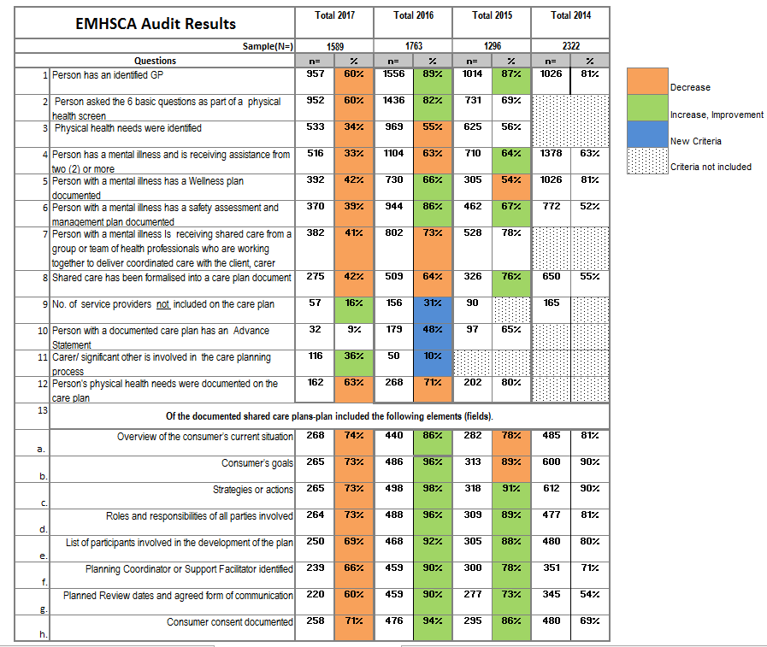

Anglicare, Eastern Health, MIND, NEAMI , Prevention and Recovery Care (PARC), Uniting care Prahran Mission,

