Report provided by Bronwyn Williams – EMHSCA Project Officer – 19th June 2017
The 10th Annual Eastern Metropolitan Region (EMR) Orientation event was held on the 18th May 2017 in the Ballroom at the Box Hill Town Hall and attracted 216 attendees in total (7% increase on 2016 attendance). This event is provided annually by the EMHSCA Workforce Development subcommittee which consists of 12 staff from a variety of EMHSCA services. A number of additional staff also assist the committee on the day of the event.
The purpose of this event is to provide a forum for new and interested staff from the EMR to learn about a range of health and community support services and meet other local staff.
A range of sectors were represented on the day including Mental Health (community and clinical), Alcohol and Other Drugs (AOD), Homelessness/Housing, Aged care services, Youth services, DHHS, DHS Centrelink, Primary Health Network, Family services, Specialist Family Violence services, Carer and Consumer groups, Partners in Recovery, education services and legal services. Almost 40% of the participants were new to the sector and 60% were not. 51% were new to their organisation and indicates that this event provides benefits to staff who are not necessarily unfamiliar with the Eastern region as well as to those who are new.

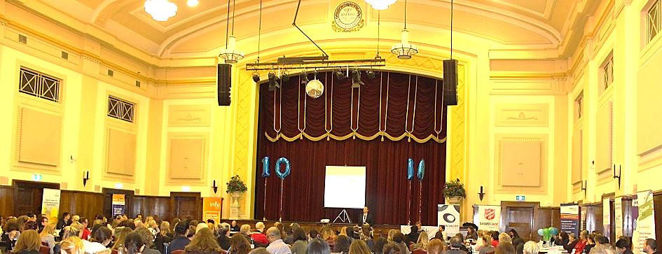
On the day
The EMHSCA project officer’s introduction encouraged participants to broaden their perspective on referral pathways and recognise their role in creating them. This was followed by consumer and carer perspectives provided by Robyn Wright and Kathy Collet. Sectoral overviews were provided from a range of local service leaders (Primary care, Homelessness, Family services, Alcohol & Other Drug, Clinical & Community Mental Health). These overviews aimed to help orient people to the various sectors (not services specifically) and highlight the sectoral differences. A game of acronym bingo was played by all and aimed to highlight the importance of breaking acronyms down when communicating with other service providers and, most importantly, with service users!
At morning tea and lunch time a marketplace which featured more than 30 service stalls was provided. The afternoon provided opportunity for participants to experience a selection from 25 workshops, 5 of which were specifically focussed on Older persons and 4 of which were focussed on Youth.

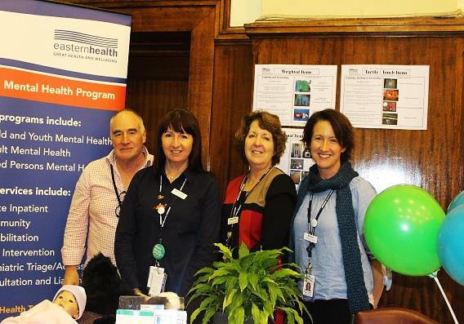
The Marketplace
The marketplace surrounded the event participants in the main ballroom allowing for service promotion throughout the morning. The colourful banners and resources provided a visual representation of the diversity of services across this region. Corey Eastwood of MIND facilitated the smooth running of this aspect of the day. A variety of services were represented including the Mental health complaints commission, Metropolitan Fire Brigade (MFB), Independent Mental Health Advocacy, Grow, Beyond Blue, Chinese Community Social Services Centre Inc., and the Eastern Community Legal Centre were made to feel at home amongst the regular Mental health, AOD, Homelessness and Aged care providers.

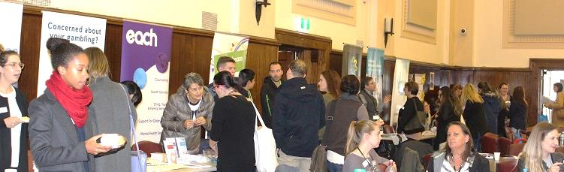
Afternoon Workshops

Participants experienced 25 presentations on a wide range of service related topics across 5 rooms of the Town hall. All were well attended and a significant improvement in attendance was noted for the Aged person’s focussed room. Deakin University staff were present in this space to introduce the Families in Later Life Study (FILLS) and seek participants. Eastern Health Forensic Mental Health specialists, Mick Wilson and Cathy Cooper, competed with Clinical Mental Health Triage and beat them to draw the largest crowd this year. Unfortunately, the Aboriginal health and well-being workshop was cancelled.
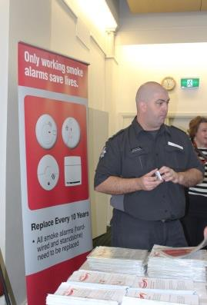
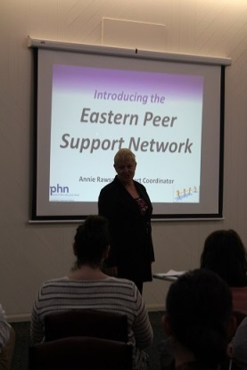
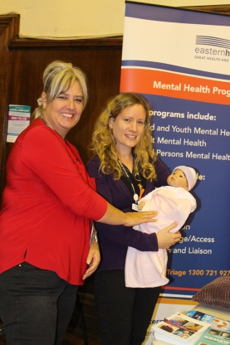
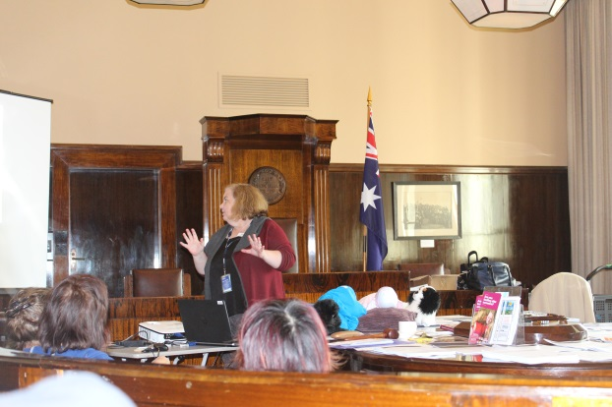

Feedback
Almost half of attendees (101 participants) completed feedback for this event. Overall the feedback from the event was encouraging with all activities being rated by the vast majority of participants as useful to very useful. On average 40-60% of information provided was new to attendees. People appreciated the numerous choices on offer in the afternoon and the high level of organisation and timing of the event. They enjoyed the networking opportunities and service information provided in the marketplace.
From the morning sessions the AOD, Homelessness and MHCSS overviews were most popular with Clinical Mental Health and the Consumer perspectives close second. The top rating afternoon workshops were Arbias, Clinical MH Triage, Carer Aware, Metropolitan Fire Brigade and ACAS –My Aged Care. All afternoon workshops were very well received by participants. The feedback reflects the diversity of the attendees with a wide range of views on what people found useful. A number of people commented that the afternoon workshops could be fewer and longer. Quite a number of comments affirmed the morning overviews and some recommended that this be extended but with more breaks. Some suggested that presenters weave case discussions through their presentations to improve engagement. Short descriptions of what is being presented in the afternoon could be included with bios to assist with choice.
When asked what they liked: “All of it! This was a very well organised and well facilitated day. Breaking up to attend sessions of choice was very good”. “Group sessions were great to tailor what we wanted to achieve – most appropriate to our field of work”. “It was really well organised – time keeping excellent, content very relevant, engaging”
When asked what people wanted more of in future: NDIS came up several times. Forensic mental health, legal services, dual diagnosis, lived experience stories, family services, accommodation options, and autism were amongst the suggestions.
When asked what we could improve for next time: A bigger screen for the morning presentations, remove round tables, reduce number of afternoon sessions and increase their length, have more case presentations, more stretches and longer early morning session, and more time for questions.
EMHSCA Workforce development committee
The Orientation event was developed, organised and provided by the EMHSCA Workforce Development subcommittee with funding via annual contributions from EMHSCA member organisations.
The committee consists of twelve members as follows:
Aaron Jones | Neami National
Anna Makris (co-chair) | Federal Dept. Human Services
Bronwyn Williams (Project Officer) | EMHSCA Service Coordination/  Eastern Health Recovery Framework Implementation
Cat Heal | Older persons services representative
Catherine Hudgson | Eastern Health Aged Persons MH
Cheryl Ritter | Eastern Health CYMHS
Corey Eastwood | MIND PARC programs
Jose Abalo (co-chair) | Federal Dept. Human Services
Kim Moreland | Eastern Health MH PDT
Maria Yap | Eastern Melbourne phn
Pembrooke Werden | Prahran Mission
Sarah Kinstler | Wellways

It is important to acknowledge the substantial contribution of these members and their teams to the success of the EMHSCA Workforce Development events each year. Thanks goes to EMHSCA member organisations for contributing in this way to improving Service Coordination across the EMR for the benefit of people with mental ill health and co-occurring issues.

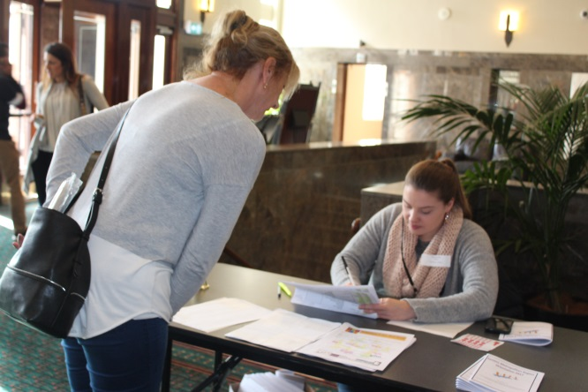
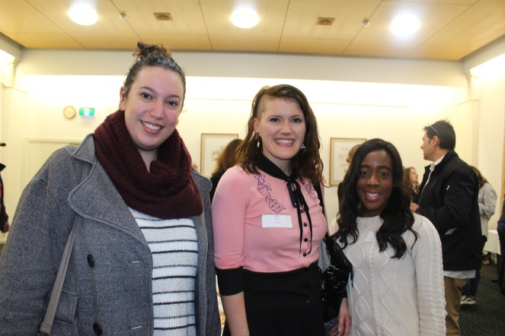

Attendance
Registered & attended | 155
Registration on the day | 61
Did not attend | 61
Total attendance | 216
NOTE: These figures may not include all marketplace stall holders and presenters
Attendance by service
Access Health and community | 1 | Headspace Hawthorn | 3
Anchor Inc. | 1 | Headspace Knox | 1
Anxiety Recovery Centre | 1 | HYPA | 1
APAT - Eastern Health | 1 | IMHA | 1
arbias | 1 | Inspiro | 1
Australian Catholic University | 1 | Life Assist | 3
Benetas Home Care | 2 | Link Health | 6
Box Hill Community Correctional Services | 1 | Manningham Council | 1
CCSSCI | 2 | MFB | 2
CHL | 2 | MIND | 8
City of Monash | 2 | Neami | 18
City of Whitehorse | 1 | UCPrahran Mission | 6
Communities Council on Ethics Issues | 1 | Reconnexion | 1
Connect4Health Consortium | 2 | Salvocare Eastern | 19
Connections | 5 | Skills & Jobs Centre - CAE | 1
CYMHS | 2 | Turning Point | 1
Deakin Uni | 2 | UC Harrison | 2
DHS | 7 | VACCA | 1
DHHS | 6 | Victoria Police | 1
Direct recruitment | 4 | Villa Maria Catholic Homes | 1
Doncare | 6 | Wellways | 7
EH APMHS | 2 | Wesley Homelessness and Support Services | 4
EACH | 7 | Yarra Valley Psychology | 2
ECLC | 6 | YSAS | 2
EDVOS | 5
Eastern Health | 32
EMPHN | 3
Gateways | 1
GROW | 1

Budget
Catering $4,000
Venue $1,655
Total: $5,655
Plus in-kind support from EMHSCA organisations for printing and staffing.
This event was within budget.
Conclusion
Now in its tenth year, this annual regional Orientation event continues to grow. Referral pathways are formed as service providers are engaged in face to face forums of this nature. The enthusiasm for this type of forum is palpable and the desire for improving our local connections is evident. With the pending introduction of NDIS to this region, EMHSCA continues to strive to preserve and grow the Eastern Metropolitan Region linkages and partnerships for the benefit of people who experience mental ill health and their families, children and other supports. Our aim is to continue to provide the EMRO into the future.

