ALLIED HEALTH RESEARCH NEWS

ISSUE 41 DECEMBER
2017
Allied Health Research News
December 2017
Allied Health Success at the
2017 Eastern Health Research Forum

The 2017 Eastern Health Research Forum was held on Thursday 7th December and was once again a great display of the depth and quality of research occurring across Eastern Health.
Allied health had excellent representa- tion from multiple disciplines and
across all presentation categories.
In the long oral presentations category,
poster “A good stepping stone to nor- mality…: Experiences of an oncology rehabilitation program.”
Guest speaker Professor Rachelle Buchbinder gave everyone in the audience plenty to think about around the issue of “Using healthcare wisely: reducing unnecessary use of tests and treatments”. Her suggestion that “a normal patient is one who hasn’t

A Research Newsletter _{for} Allied Health Clinicians
Inside this issue:
psychologist Victoria Manning from Turning Point spoke about problem gambling use in patients attending mental health services, Kylee Lock- wood presented on the feasibility of conducting a randomised control looking at occupational therapy home visits with patients after hip fracture, and Judi Porter shared insights from her stepped wedge trial investigating the effectiveness of protected meal times as a malnutrition intervention. All were high quality presentations,
highlighting the diversity in allied health research. The award for best presenta- tion in this section went to a point prev- alence study of delirium and cognitive impairment at Eastern Health, present- ed by Penelope Casey (Nursing).
Knee OA and cardio- vascular risk | 2
Does clinical supervision improve patient outcomes? | 3
AH team receive grant to study metabolic syndrome | 3
Euan’s Musings | 4
Allied Health Research Clinics—2018 | 4
Allied Health Research Achievements | 5

Rebecca Sullivan (Speech Pathology) flew the flag for Allied Health in the short presentations section, and it was great to see her receive the
award for best presentation in this category! Rebecca shared her findings from an audit of stroke survivors in rehab- ilitation, demonstrating the importance of communication disorders as a risk factor for
had enough tests” may have been made in jest, but there were important messages in her presentation about the dangers of overtreatment, and the enormous costs of this issue to our health system.
The forum also marked the launch of the 2017 research report, which this year features work by Allied Health researchers Amy Dennett and Kylee Lockwood. Finally, successful recipients of the 2017 EH Foundation grants round were announced, and we congratulate Nick Taylor on receipt of one of these awards. See page 4 for
further details.
Thanks to the staff of the Office of Research and Ethics for organising this event.
Rebecca Sullivan receives her award for
best short presentation, along with Penelope Casey (best long presentation) and Director of Research and Medical
Services, Colin Feekery.

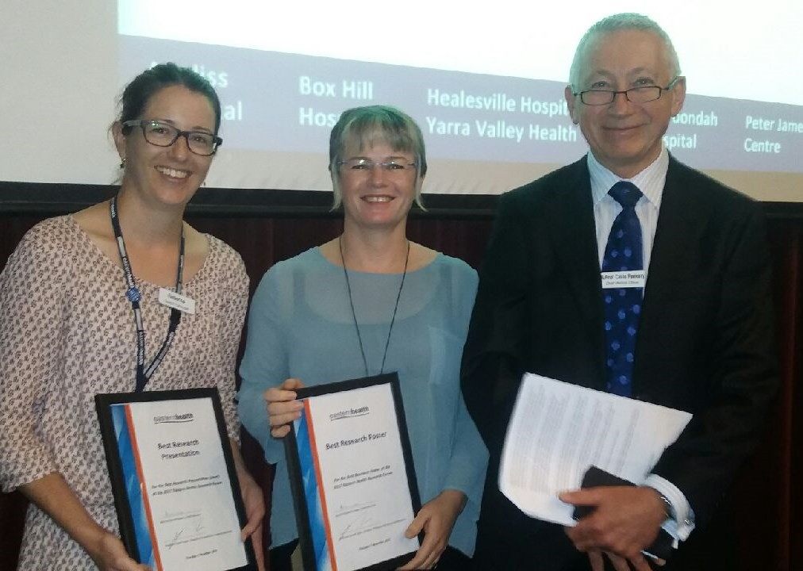
falls in this population.
Allied Health had further success in the posters category, with several great posters on display and the best poster award taken out by physio- therapist Amy Dennett, for her

ALLIED HEALTH RESEARCH NEWS DECEMBER 2017
Page 2

Perceptions of a walking program for people with knee OA and cardiovascular risk

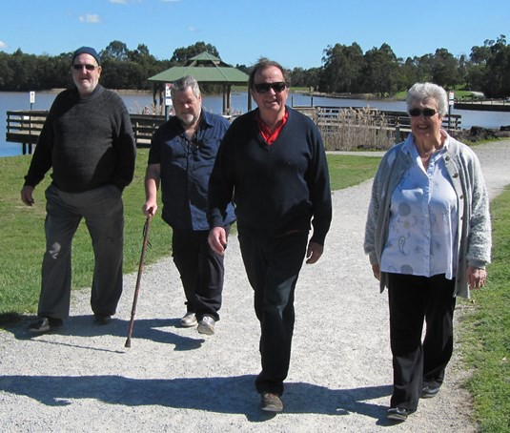
People with osteoarthritis of the knee often have low physical activity levels and high risks of mortality from cardiovascular disease. Joint replacement is often seen as the cornerstone of management for this patient group, but does not necessarily lead to higher physical activity levels.
PhD student and physiotherapist Jason Wallis demonstrated in a randomized controlled trial that 70 minutes of moderate intensity physical activity each week delivered through a walking program leads to cardiovascular benefits without increasing pain.
However, the potential success of such programs is dependent on adherence, which is heavily influenced by people’s thoughts, perceptions, attitudes and beliefs about the risks and benefits of participation.
To further explore this issue, Jason has completed a qualitative study with 21 people with severe knee osteoarthritis and increased cardiovascular risk who participating in a 12 week walking program. Interviews were audiotaped, transcribed, member-checked, coded and themes developed using thematic analysis.
The main theme identified was the preoccupation with the knee including pain, damage and the view that surgery was required.

“It’s not going to fix my knees because you can’t. There’s only one way and that’s the operation”
Three subthemes to emerge were:
- The perception of functional, cardiovascular and psychosocial benefits with the walking program.

“The result is I’m more mobile. So being able to do more around the house, you know, like getting up out of a chair has been easier. It hasn’t been a struggle.”
- That supervision, monitoring and commitment were important enablers;

“Without it (pedometer) I probably wouldn’t have done the 10-min walk every day...so it’s been motivating”
“It got me off my backside. I’m a lazy person and it just made me do it.”
- External factors such as ill-health, weather and the environment were key barriers.

“If it’s stormy out, I won’t go walking, if it’s hot or 30 odd degrees I
probably won’t go for a walk either.”
The study concluded that even when patients with severe osteoarthritis of the knee report other benefits from participating in a walking program, the core theme to emerge was their preoccupation with knee pain, knee damage and the view that they needed a knee replacement. As one participant summed it up,

‘I’ve got a knee that’s absolutely shot, and buggered’.
Jason’s study highlights the challenges in promoting physical activity for patients with severe knee osteoarthritis.
This work won an award for best poster at the joint annual scientific meeting of the Australian and New Zealand Rheumatology Associations in Auckland earlier this year, and has recently been accepted for publication in Disability and Rehabilitation:

Wallis JA, Webster KE, Levinger P, Singh PJ, Fong C, Taylor NF. (in press). Perceptions about participation in a 12-week walking program for people with severe knee osteo-arthritis: A qualitative analysis. Disability and Rehabilitation
http://www.tandfonline.com/doi/ full/10.1080/09638288.2017.1408710

ALLIED HEALTH RESEARCH NEWS DECEMBER 2017 Page 3
Does clinical supervision of healthcare professionals improve effectiveness of care and patient experience?

While clinical supervision of health professionals has been shown to improve patient safety, its effect on other dimensions of quality of care is unknown. As part of his PhD studies, physiotherapist David Snowdon set out to determine whether clinical supervision of health professionals improves effectiveness of care and patient experience.
Key health service databases were searched and inclusion and exclusion criteria were applied using accepted methodology for systematic reviews. The quality of each study was rated using the Medical Education Research Study Quality Instrument, and data were extracted on effectiveness of care (process of care and patient health outcomes) and patient experience.
Seventeen studies across multiple health professions (medical (n=4),
nursing (n = 7), allied health (n=2) and combination of nursing, medical and/or allied health (n = 4)) met the inclusion criteria. Twelve of 14 studies investigating 38,483 episodes of care found that clinical supervision improved the process of care. This effect was most predominant in cardiopulmonary resuscitation and African health settings. Three of six studies investigating 1756 patients found that clinical supervision improved patient health outcomes, namely neurological recovery post cardio- pulmonary resuscitation (n=1) and psychological symptom severity (n=2). None of three studies investi- gating 1856 patients found that clinical supervision had an effect on patient experience.
Clinical supervision of health professionals is associated with effectiveness of care. The review found significant improvement in the process of care that may
improve compliance with processes that are associated with enhanced patient health outcomes. While few studies found a direct effect on patient health outcomes, when provided to mental health professionals clinical supervision may be associated with a reduction in psychological symptoms of patients diagnosed with a mental illness. There was no association found between clinical supervi- sion and the patient experience dimension of quality of care.

Read the full version of this paper in:

Snowdon DA, Leggat SG, & Taylor NF. Does clinical supervision of healthcare professionals improve
effectiveness of care and patient experience? A systematic review. BMC Health Services Research 17:286.

Allied Health led team receive Eastern Health Foundation Grant to investigate metabolic syndrome
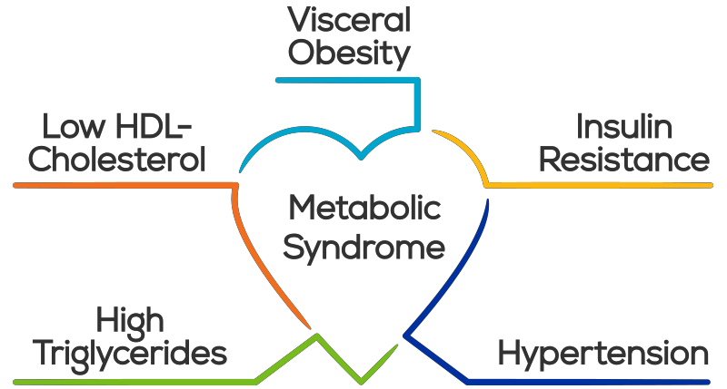
Metabolic syndrome is a group of factors that commonly occur together to raise the risk of chronic disease. Diagnosis of metabolic syndrome is based on an individual having at least three of five metabolic risk factors.

Congratulations to the research team: Professor Nick Taylor, Dr Casey Peiris, Professor Chris Gilfillan, Dr Judi Porter and Professor Nora Shields,
Thanks to the Eastern Health Foundation and donors who make these grants possible.
The diagnosis of metabolic syndrome provides a key opport- unity to identify the people most at risk and to implement intervention to prevent disease progression and subsequent healthcare burden

and costs.
Community rehabilitation physio- therapists and dietitians are ideally placed to monitor incidence of metabolic syndrome and implement preventative lifestyle interventions and health promotion strategies.
This research aims to determine the prevalence of metabolic syndrome in patients attending community rehabilitation services at Eastern Health, and to compare health literacy and physical activity levels of people with and without metabolic syndrome. The results of this research will inform the need for, and the development of, services to manage metabolic syndrome, to prevent progression to chronic disease and ultimately reduce healthcare costs.

ALLIED HEALTH RESEARCH NEWS DECEMBER 2017
Page 4

Euan’s Musings

Still intact (just!)

Euan is close to the end of his PhD (and sanity) and works in Emergency with the psychiatric ^
team.
The Weakest Link
I was once cool like you. I used to be a club and radio DJ. I was paid to play A.B. Logic and Ace of Base. Times were good.
There was a build up to this. In the years preceding my coolness I was a wedding DJ. Too. Many. Damn. Weddings. If you were married in the last 10-20 years then allow me to relive some of your reception music playlist; My Sharona, Come on Eileen, Knock on Wood, Born to be alive, Dancing Queen, Respect (Madonna or Aretha version). If there were older people, just add Jive Bunny. As a wedding DJ I had developed a sound methodology: wedding + crappy music = dancing (extraneous variable +/- alcohol consumed). Any significant deviation to this methodology ran the risk of dance floor mass exit to a table of dessert, coffee and never shall to return to the
disco ball.
And what exactly does this have to do with research? Well, your chosen research methodology must be reliable and sound. Even a small error or deviation in accepted standards may discredit your results. So have your research aim (wedding), your population (guests) and your methodology (crappy music) well planned or your dance floor may be empty.
Or I could have just said, “watch out for your weakest link”, but that would be under my word limit.
EUAN DONLEY

Need some advice on a research idea?
Come and have a chat to an experienced researcher at one of our allied health research clinics.
Hot ofF the
press!
Congratulations
Dr Euan Donley
on successful completion of his PhD!
Stay tuned for some even more learned musings from dr donley in coming issues!

Site | Date | Contact
Peter James Centre | 19th April, 8.30-10.30 | Katherine.Harding@easternhealth.org.au
Maroondah Hospital | 26th April, 8.30-10.30 | Katherine.Harding@easternhealth.org.au
Wantirna Health | 3rd May, 9.30-11.30 | Katherine.Harding@easternhealth.org.au
Yarra Ranges Health | 31st may, 8.30-10.30 | Judi.porter@easternhealth.org.au
Box Hill Hospital | Make an appointment any time | Katherine.Harding@easternhealth.org.au or  Nicholas.taylor@easternhealth.org.au
Angliss Hospital |  | Judi.porter@easternhealth.org.au

Page 5
ALLIED HEALTH RESEARCH NEWS DECEMBER

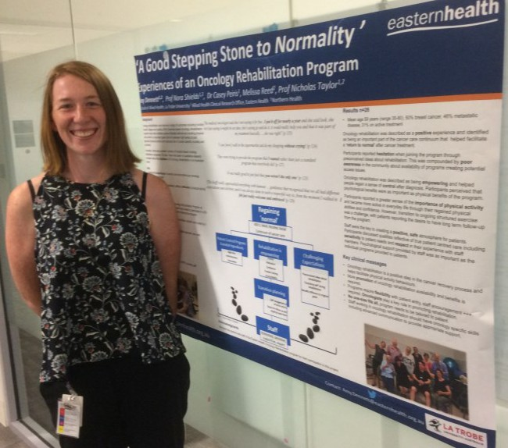
Allied Health Research Achievements
Publications:
Andrea Bruder
Bruder AM, Shields N, Dodd K, Taylor N. Prescribed exercise programs may not be effective in reducing impairments and improving activity during upper limb fracture rehabilitation: a systematic review. Journal of Physiotherapy 63 (4), 205-220.
David Snowdon
Snowdon DA, Leggat SG, & Taylor NF. Does clinical supervision of healthcare professionals improve effectiveness of care and patient experience? A systematic review. BMC Health Services Research 17:286.
Jason Wallis
Wallis JA, Webster KE, Levinger P, Singh PJ, Fong C and Taylor NF (2017). "Perceptions about participation in a 12-week walking program for people with severe knee osteoarthritis: a qualitative analysis." Disability & Rehabilitation: 1-7.

Conference Presentations:
Australasian Society of Parenteral and Enteral Nutrition (AuSPEN), Gold Coast, 16-18th November 2017:
- Emma Armstrong: What’s the missing piece of our parenteral puzzle? (poster)
- Lina Breik: Enteral nutrition – Evidently not! (poster)

Constance Schneider: Evaluation of the management of behavioural symptoms of dementia in Transition Care. Australian Association of Gerontology conference, Perth, Nov 2017.

VictorianHealth Service Social Workers Symposium, October 2017:
- Glenda Kerridge – Leadership and career development: the international leadership program in the Department of Social Work Services at Mt Sinai Medical Centre, New York
- Belinda Ross and Glenda Kerridge – The 7 Steps to Residential Care: Raising visibility across the organisation

Amy Dennett with her award winning poster from the 2017 EH Research Forum

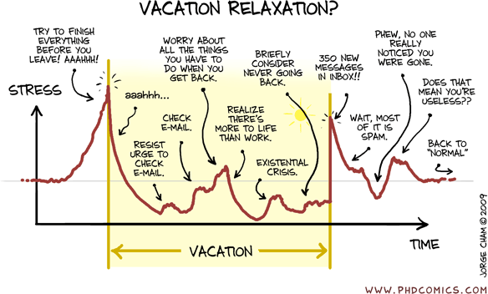
Follow us on Twitter!

“Vacation v. stress” By Jorge Cham www.phdcomics.com

@EH_Research

Do you have anything of interest to report in this newsletter? Please forward your articles and achievements to:
Allied Health Research Committee
Nick Taylor Judi Porter
Katherine Harding Euan Donley
Anne Thompson Lauren Lynch
Jason Wallis Anna Joy
Alison Wilby Glenda Kerridge
Sarah Dallimore Judy Bottrell

Allied Health Clinical Research Office Telephone: 9091 8880 or 9091 8874 nicholas.taylor@easternhealth.org.au katherine.harding@easternhealth.org.au

