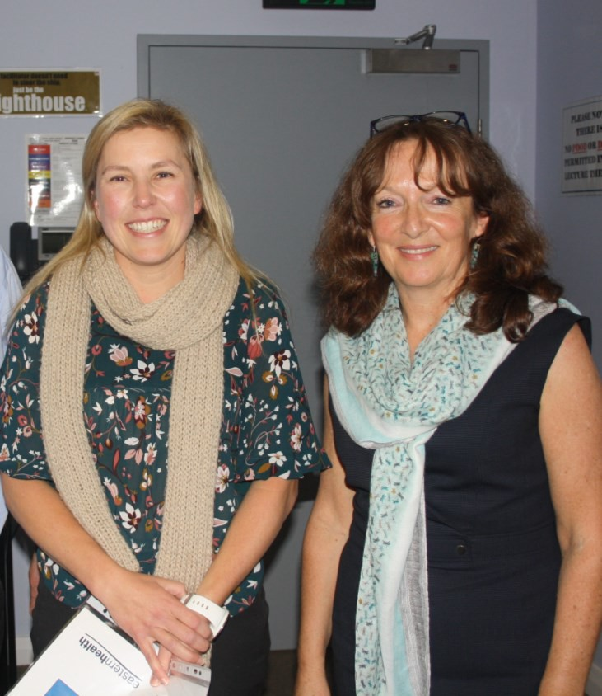
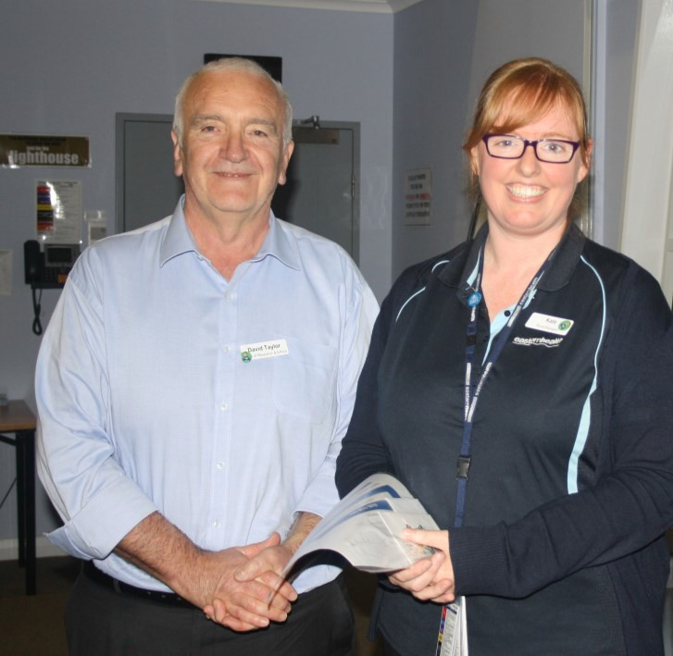
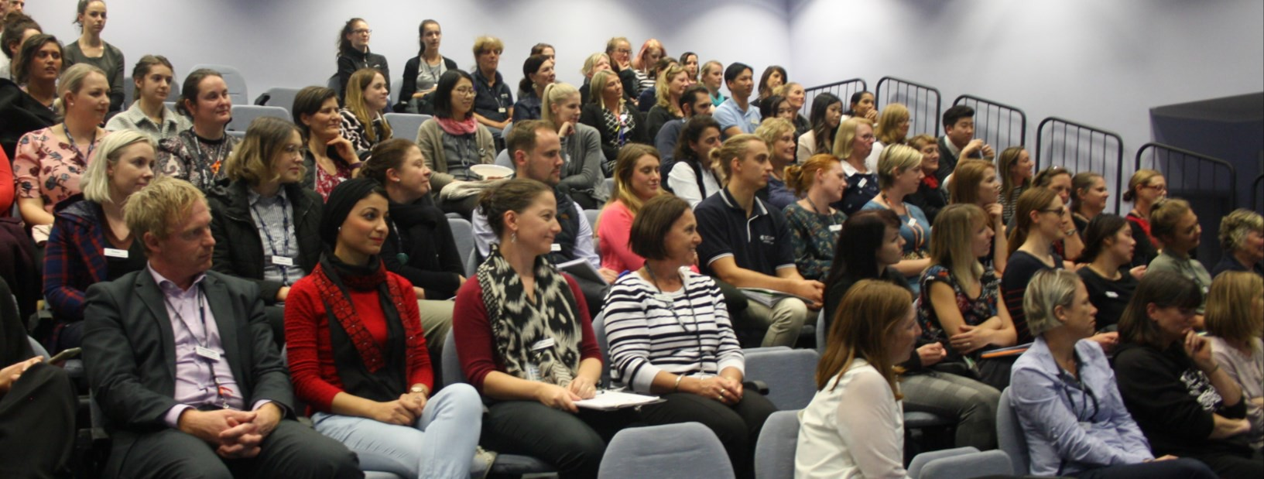
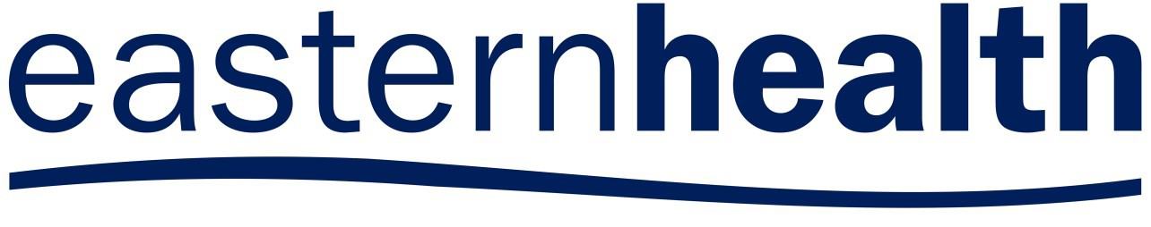

ALLIED HEALTH RESEARCH NEWS

ISSUE 43
JUNE 2018

A Research Newsletter _{for} Allied Health Clinicians
Inside this issue:

Winning work from the 2018 AH Research Forum | 2
Pros and cons of being a data collection site | 3
Dietetics association of Australia Conference | 4
Stepping into research participants 2018 | 5
Euan’s musings: Managing Expectations | 6
Allied Health research achievements | 7
Allied Health Research News JUNE 2018
2018 Allied Health Research Forum

On Thursday 10 May, 14 courageous and talented allied health researchers presented their work to a capacity lecture theatre at Wantirna Health at the annual Allied Health Research Forum as part of the 3-Minute Presentation competition.
The presentations covered delirium, core stability, physical activity for various conditions, hospital food services and more. The audience were treated to an array of inspiring presentations showcas- ing the research being undertaken across Eastern Health by our very own clinicians.
Congratulations to Kate Lawler for the People’s Choice Award and to Andrea Bruder, the overall winner of the competition. For more information about their presentations see page 2.
Research was also on display in the form of a fabulous display of posters that have been featured at conferences across the country and in some cases internationally over the last 12 months. These really highlight the breadth and quality of research being conducted by allied health
staff.
In addition to staff presentations, Professor Miranda Rose, Director of the Aphasia Lab and Research Fellow, La Trobe University, provided an amazing insight into her own journey as a researcher and reminded us all that clinicians are in the perfect position to be contributing to the knowledge and
evidence to improve patient outcomes.

Top: Best presentation winner, Andrea Bruder with guest speaker Professor Miranda Rose.
Middle: People’s choice winner,
Kate Lawler with Director of Research and University Partnerships, David Taylor.
Bottom: A full house for the 2018 forum

ALLIED HEALTH RESEARCH NEWS JUNE 2018 Page 2
Winning work from the 2018 Allied Health Research Forum
Need some inspiration for next year’s Allied Health Research Forum? These transcripts of this year’s winning presentations are great examples of how to tell your research story in 3 minutes.
Congratulations to Andrea and Kate on these excellent pieces of work.
Andrea Bruder: Judges Award Kate Lawler: People’s Choice Award

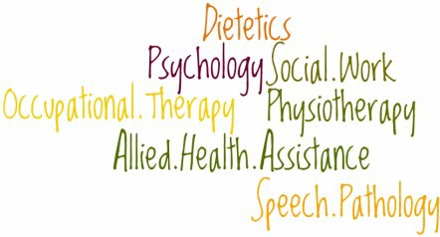
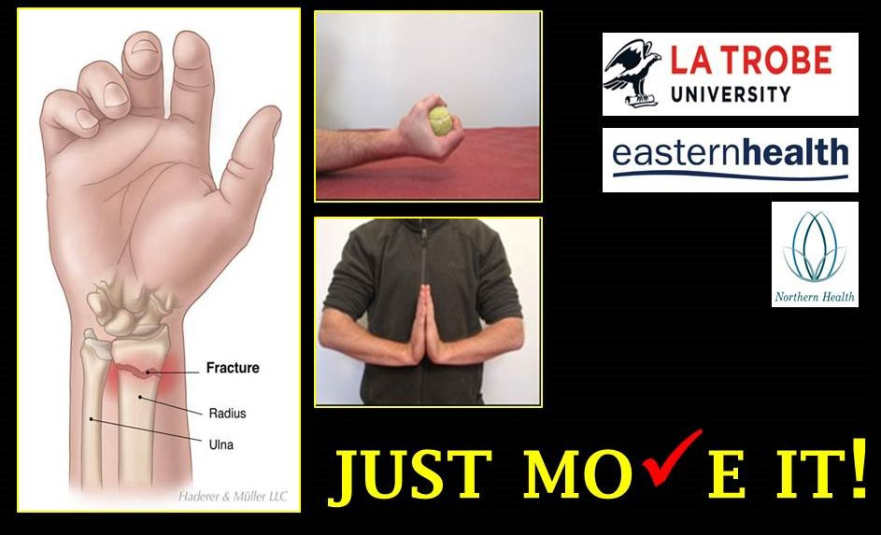
Fractures of the wrist are one of the most common
upper limb fractures –
EUAN DONLEY
1 in 7 women will experience a wrist fracture wrist during their lifetime.
People are often referred to physio-therapy for rehabilitation to return to pre-injury function.
Exercise is one intervention proven to be beneficial in rehabilitation across many health conditions. I conducted a systematic review to find out if this was the case for recovery of an upper limb fracture. My findings revealed a gap as no study had investigated a program of exercise in a trial after upper limb fracture – so it meant we just didn’t know if exercise was effective in this group or not. This gap in the literature was surprising because our survey of what Physiotherapists were doing with their patients after wrist fractures showed that exercise, and also advice, were used with almost every patient and in every consultation. So we think exercise is important in upper limb fracture rehabilitation, and we know that Physiotherapists prescribe exercise in almost every treatment session, yet we didn’t know if it was an effective intervention or not!
I conducted a trial investigating the effect of a program of advice and progressive exercises after a wrist fracture compared to advice only. This program was delivered over three consultations with a physiotherapist once the cast was removed. The comparison was the same advice program over three consultations with a physiotherapist. And what did we find? That comprehensive advice provided regularly by a Physiotherapist may be as effective as an exercise program that is completed three times per day for six weeks. There were no differences between the groups (they in fact both did well!) for any measures of activity or impairment, such as wrist function, range of movement or grip strength. Looking at the components of the program of advice, encouraging movement and progressively returning to activities of daily living was discussed in every treatment session.

One interpretation of our trial findings is that physio- therapists should continue to provide comprehensive advice that encourages people to move their injured arm and that this may be as important as prescribing set exercises.
Consistent with the findings of our updated systematic review, there is emerging evidence that the way in which we currently prescribe exercise may not be effective in reducing problems such as muscle weakness and improving activity after a wrist fracture. So, what does it all mean? My thesis has found that when therapists are faced with the question by the patients….What should I do to help my recovery after wrist fracture? Their reassuring and motivating response should be….Just move it!
I would benefit from more healthy food in my life, and more relaxation. Some of you might be looking for more money or more happiness.

But is more always better?

Is more better? Results of the SatGEM trial
Nicholas Taylor, Katherine Lawler, Peteris Darzins, Nora Shields, Jude Boyd, Anita Wilton, Casey Peiris, Natasha Brusco, Katherine Harding, Daniel Raftis, Grant Scroggie, John Ferraro
Today I’m sharing the results of the SatGEM trial which aimed to discover whether more is better when it comes to allied health services in geriatric evaluation and management (or GEM). You see, we already know that more is better in rehab. A few years ago, Eastern Health ran a randomised trial with almost 1000 rehab patients and found that physiotherapy and occupational therapy on a weekend, in addition to weekday therapy, improved patients function and quality of life, and had a positive impact on length of stay. So what about in GEM?
Given the complexities faced by patients in GEM, we wanted to investigate additional therapy from all the professions noted on my slide, not just physio and OT. We collected data for 6 months from two of our GEM units in two consecutive years for a total of 793 patients. The first six months was our baseline, and during the second six months we ran a full allied health service on Saturdays on North Ward here at Wantirna, and Box Hill 9.1 continued as our usual care comparison with no therapy on weekends. We measured outcomes related to patient function, length of stay and readmissions to hospital.
And the results were not what we expected. Length of stay reduced on 9.1 – our usual care ward – not at Wantirna where we had the extra therapy program!
But before you all panic and think that allied health is pointless and we should all go home… there is another layer to the story. While Box Hill length of stay reduced, so did the functional level patients reached before going
home, and it looks like these patients were readmitted to hospital more often. On the other hand, the team on Wantirna North ward had been managing extra patients via patients admitted for GEM in neighbouring East ward, but was able to maintain the same length of stay, and the same functional level for patients compared to the year before, with what looks to be 44% less readmissions when compared with Box Hill.
So maybe more is better, but in a different way for GEM compared to rehab. And should we be planning additional allied health services for GEM on weekends in the future? To answer this question we need to know whether we can afford it – does the service provide the taxpayer with
value for money? We’re currently on the brink of securing the economic data we need to answer this question, and look forward to sharing the answer with you as soon as possible. Stay tuned!

ALLIED HEALTH RESEARCH NEWS JUNE 2018

So you’ve been asked to be a data collection site….
Page 3

In the past few months a few enquiries have come through the allied health research office about invitations to Eastern Health clinicians to collect data for an existing external research project. So is this a good thing or a bad thing? If you get an invitation like this, what should you say?
What does it mean to be a data collection site?
Researchers undertaking large projects often need to recruit participants or collect data from multiple sites. This is often simply to reach the required number of participants, but also might be a
research’ and provides patients with opportunities to take part in trials that could benefit their care. In big trials it is also quite common for data collection sites to be paid an administration fee for each participant recruited.
The Challenges
The biggest challenge in collecting data for someone
else’s research is to make sure that expectations are clear on both sides. The research team is responsible for running the project. That includes getting all required ethical approval, designing the protocol and
The Upshot Participating in a large
research project as a data collection site can be a great thing for clinicians, patients and the health service.
Clinicians should
just be very clear about expectations, responsibilities, incentives and credit and make sure they are comfortable with these arrangements before
signing up.

“What’s in it for me?”

deliberate effort to collect data from different types of patients or health services.
Projects conducted in this way are still ‘owned’ and managed by the research team. The research team shoulder most of the
providing all required information and training.
The research team is also responsible for analysing the data and writing up results. Sometimes people who assist with collecting data are invited
Sites

Contribution to service/ profession
Experience

Research Team
RESPONSIBILITY CREDIT
Sites

May be paid

responsibility, and get most of the credit.
The Benefits
Collecting data for someone else’s project can be a great way to get some experience of being involved in a research project with a small amount of effort and minimal responsibility. This can also be a good opportunity to meet people directly involved in research and get a taste for whether this is something you might like to do more of in the future. You also have the satisfaction of knowing that you are playing a small part in building the evidence base in your profession. Participating in research is also positive at a service level, as it helps to
Typical Roles and responsibilities
Research team
- Design project
- Get ALL required ethical approvals
- Provide training/instruction to data collectors
- Analyse data
- Authorship of related publications
Clinicians at data collection site
- Follow the protocol as agreed and directed by research team
- Will often include recruitment and consent procedures
- Accurate data recording
- No expectation of authorship
- May be paid a fee for recruitment

contribute to a ’culture of
to be authors on publications, but this should not be expected or assumed and will only be the case if they meet specific requirements for authorship.
Sites Sites
Satisfaction

Page 4 ALLIED HEALTH RESEARCH NEWS JUNE 2018

Eastern Health well represented at the
Dietetics Association of Australia National Conference
The Dietetics Association of Australia held their 35th national conference in Sydney on 17th-19th May 2018 and it was great to see that Eastern Health was well represented. Judi Porter delivered two pre-conference workshops, and Eastern Health staff presented two oral presentations and 12 posters.

Congratulations to everyone who participated!

Oral Presentations:

Porter J, Haines T, Truby H. Protected Mealtimes: results of a clinical trial and future directions.
- Collins J, Brennan E, Porter J. Nutritional adequacy and foodservice satisfaction of adults admitted to mental health wards.
Posters:
- Adamski M, Collins J, Twohig C, Mugia C. Opportuntiies for training for nutritional professionals in nutritional genomics: What's out there?
- Armstrong E, Jamieson R, Porter J. Vitamin C content of foods served in hospitals or aged care facilities is reduced secondary to food service models: a systematic review.
- Berlandier M, Collins J. Cost and waste of supplements automatically provided to patients requiring a texture modified diet.
- Brennan E, Collins J Are moulded texture modified meals the way to go? A pilot study to evaluate quality, implications for patients and food service.
- Brennan E, Collins J. How do you achieve 100% patient meal satisfaction on a maternity ward? Provide a flexible food service model designed to meet the patients schedule and mums will love it!
- Dewar S, Porter J. Evidence based nutrition clinical care pathways: a systematic review of their effect on nutrition outcomes in
non-surgical cancer patients.
- McGrice M, Mitchell H Complex nutritional complications during pregnancy post bariatric surgery: a case report.
- Mitchell H, Armstrong E. Low FODMAP and gluten free hospital menus - patient satisfaction levels and innovative innoventions.

Emma Armstrong (top) and Hannah Mitchell (bottom) with their posters

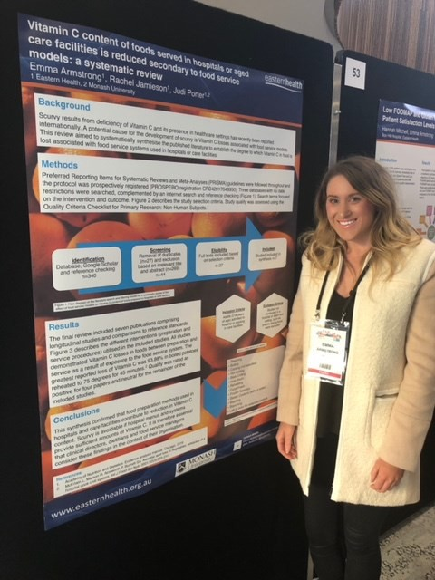
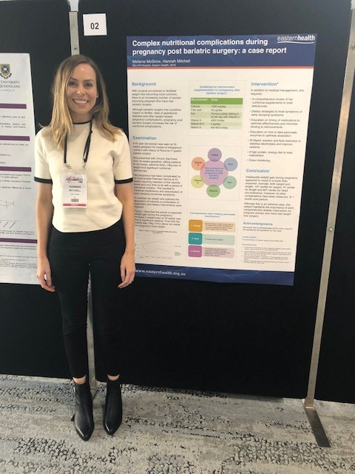
Ottrey E, Porter J, Huggins CE, Palermo C. “Meal Realities” in hospital: exploring mealtimes using an ethnographic approach.
- Porter J, Brennan E, Wilton A. Professional identity: how do dietitians compare with other allied health staff? Nutrition & Dietetics,
- Slater S, Wade K, Collins J. Volunteer mealtime practices in geriatric evaluation and management.
- Twohig C, Collins J, Murgia C, Adamski M. Nutritional genomics for nutrition professionals: who undertakes online training and are they more knowledgeable, confident and involved?

Abstracts for all of the presentations can be found in Nutrition and Dietetics (Vol 75, Supplement 1).

ALLIED HEALTH RESEARCH NEWS JUNE 2018
Page 5

Our next cohort to
‘Step into Research’

Stepping into Research Training Scheme, 2018

Congratulations to our group of successful applicants who have stepped forward for this year’s ‘Stepping into Research’ training scheme. We continue to be impressed by the high standard of applications received for this program. Good luck to all our participants!
2018 Participants
Bronte Young, Occupational Therapist GEM@Home, Wantirna Health Dina Porgebnoy, Physiotherapist
Community Rehabilitation Program, Wantirna Health and PJC Tamara Milborn, Physiotherapist
HARP, Wantirna Health
Kevin Vuong, Occupational Therapist Community Rehabilitation Program/ Transition Care
Maria Van Namen, Physiotherapist GEM, Peter James Centre
Rebecca Sullivan, Speech Pathologist Peter James Centre

Thanks to our mentors for this year’s program: Nick Taylor, Amy Dennett, Casey Peiris, Judi Porter, Kylee Lockwood, Lauren Lynch and Rebecca Nicks.

ALLIED HEALTH RESEARCH NEWS JUNE 2018
Euan’s Musings
Dr Euan Donley is the Clinical Specialist for the Mental Health Access Team. Feel sorry for those he is responsible for.
Page 6

MANAGING EXPECTATIONS
Allied Health Research ‘Comings and Goings’
There will be some changing faces in Allied Health Research over the second half of 2018.
Sadly, in July we farewell David Snowdon. David has been working with the AHCRO over the last 2 years as a project officer on the STAT project. During this time he has also been working towards his PhD on models of supervision in allied health. David has been successful in being appointed to a the Grade 4 position in Research and Translation at
Peninsula Health.
David has been a valued member of the physiotherapy team, and over the last two years has been a highly valued member of the STAT research project team and the Allied Health Clinical Research Office. Eastern Health Physiotherapy are also incredibly grateful for his valued contributions to understanding and improving the effectiveness of clinical supervision in our profession and allied health more broadly - his work will shape supervision models and clinician growth for years to come. We wish David all the best in
his new role.
Katherine Harding will also be temporarily away from the AHCRO, taking a period of long service leave from July—October 2018. During this period Anne Thompson will be Acting Manager of the AHCRO.
We also would like to extend a warm welcome to Rebecca Nicks, who is joining the Occupational Therapy team in a Grade 4 role while Anna Joy is on maternity leave. Rebecca has considerable research experience and track record of publications. We look forward to having the benefit of her Rebecca’s
expertise as a mentor in this year’s Stepping into Research program and working with her in over the coming months.

So I am fortunate to have completed my PhD. So
that’s nice. Nearly 8 years were not entirely wasted and now some time to celebrate a milestone.
However.
When I told my young children that Dad was a doc- tor their response was, “Noooooo!” I looked out- side; the sun was still yellow, the sky still blue, and the moon did not appear to change shape. I don’t
mention my PhD to patients, but I imagine when you are in an ED in crisis, you could care less about it. I noticed there were still dishes to be done at home, kids wanting food, bills still insisted on being paid, my clothes still need washing, my runners stink, and I am still slightly too short.
When I walked the street, no strangers came up to me and said, “Hey, you’re that new doctor. I loved your mixed-method analysis on the nature of dynam- ic risks shifting because of political and organisa-
tional policy.” No one has asked for my autograph (unless an updated working with children check counts, and it does, so count it!). During my gradua- tion, when on stage I sat when I should have
stood. Seemed a basic principle but I could not manage it. The only time I am called doctor, is when I do something stupid at work and I am told, “Nice
one…doctor”.
Somewhere, as always, my point is hidden.
The point, I think, is that if you are researching / studying for a major life change that may well hap- pen. But don’t make it your goal. My goal was to get mental health research in the Emergency De- partment out in the world, and get a qualification while I did it. Along the way, I hoped it helped con- sumers and staff. I shan’t bore you with how that happened, but my goal was achieved.
So keep yourself grounded when you can, and re- member that while your research is important, it does not mean your runners no longer stink.

Do you need some assistance with a research question?
No further formal research clinics are scheduled for 2018. However any allied health clinicians wanting research advice are welcome to contact:
Nick Taylor (BHH) Nicholas.taylor@easternhealth.org.au Judi Porter (Angliss) Judi.porter@easternhealth.org.au

Page 7
ALLIED HEALTH RESEARCH NEWS JUNE 2018

Allied Health Research Achievements
Do you have anything of interest to report in this newsletter?
Please forward your articles and achievements to:

Allied Health Clinical Research Office

Telephone: 9091 8880 or
9091 8874

nicholas.taylor@ easternhealth.org.au

katherine.harding@ easternhealth.org.au
Publications
Kate Henderson (Physiotherapy—Stepping into Research participant)
Henderson KG, Wallis JA, Snowdon DA. Active physiotherapy interventions following total knee arthroplasty in the hospital and inpatient rehabilitation settings. A systematic review and meta- analysis. Physiotherapy (in press).

Amy Dennett (Physiotherapy)
Dennett A, Shields N, Peiris C, Reed M, O'Halloran P, Taylor N. Does psycho-education added to oncology rehabilitation improve physical activity and other health outcomes? A systematic review. Rehabilitation Oncology (in press).

Andrea Bruder (PhD candidate, Physiotherapy)
Bruder A, McClelland J, Shields N, Dodd K, Hau R, van de Water A, Taylor N. Validity and reliability of an activity monitor to quantify arm movements and activity in adults following distal radius frac- ture. Disability & Rehabilitation (in press).

Claire Leipold and colleagues (Dietetics)
Leipold CE, Bertino SB, L'Huillier HM, Howell PM, Rosenkotter M. Validation of the Malnutrition Screening Tool for use in a Community Rehabilitation Program. Nutrition & Dietetics 2018; 75 (1):117-122.

Cathryn Baldwin and colleagues (Occupational Therapy)
Baldwin C, Power L, Wilkinson A, Pope K, Harding K. Modified Constraint Induced Movement Ther- apy is a feasible and potentially useful addition to the Community Rehabilitation tool kit after stroke: A pilot randomised control trial. Australian Occupational Therapy Journal (in press).

Jo Brady (Speech Pathology)
Brady J, Harding K. Clinical Judgement Just as Reliable as an Explicit Prioritisation Tool: A Compar- ison of Three Prioritisation Approaches for Inpatient Speech Pathology. International Journal of Speech-Language Pathology (in press).

@EH_Research
Conference Presentations:

David Snowdon (Allied Health Clinical Research Office)
Canadian Association for Health Services and Policy Research Conference, Montreal, 29th-31st May 2018.
- Peer review of physiotherapists managing patients with hip fracture can improve compliance with guidelines: a before-and-after observation study
- Reducing waiting time in ambulatory and community health services: A Stepped Wedge Cluster RCT
Allied Health Research
Committee
Nick Taylor Katherine Harding Jason Wallis (PT) Alison Wilby (Psych)
Anne Thompson (ACS) Sarah Dallimore (Pod) Judi Porter (Dietetics) Euan Donley (Mental Health)
Lauren Lynch (SP) Anna Joy (OT)
Glenda Kerridge (SW)
Judy Bottrell (PT)

Katherine Harding (Allied Health Clinical Research Office)
Improving quality of care by reducing waiting time in outpatient services International Forum for Quality and Safety in Healthcare in Amsterdam, May 2-4th.

Sarah Dallimore and Fran St Ruth (Podiatry)
Managing Foot Wounds (workshop for private practitioners), Australian Podiatry Conference, Melbourne 27th April.

Rebecca Sullivan
Sullivan and Harding Speech Pathologists have a vital role in post stroke falls prevention in hospitals: a retrospective audit. Speech Patholgoy Australia National Conference, Adelaide, 27-30th May.

Chris Bruce and Lauren Lynch
Do patients with a communication difficulty have a different experience of care when compared to patients without

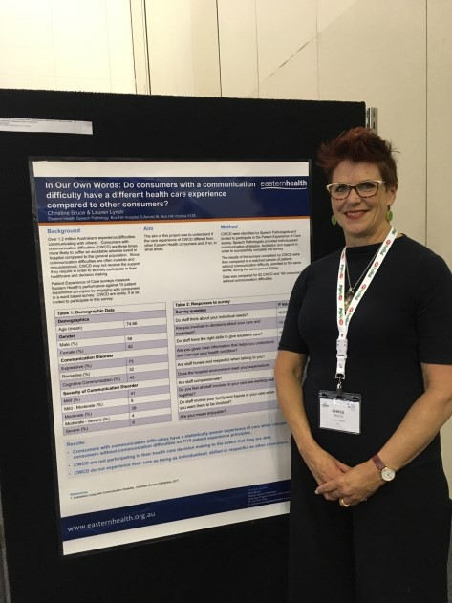
communication difficulty. Speech Patholgoy Australia National Conference, Adelaide, 27th-30th May 2018
Chris Bruce presents her poster at the SP Australia National Conference

