Edition Number 2 Autumn 2018
The Meteor
News from the Dual Diagnosis Service
& Dual Diagnosis Consumer & Carer Advisory Council

Editorial
This edition of the Meteor highlights dual diagnosis and con- sumer and carer events and developments in the Eastern re- gion. Regular columnists Russell Chilcott and Fred Murray make their contributions, as does Kellie O`Connor from Chan- dler House community metal health centre and Sarah Martin, Art Therapist at the Wellington House residential withdrawal unit. The Dual Diagnosis Service has welcomed two new senior clinicians, Carol Addicoat and Peter Fairbanks, and in early May we were joined by three new clinically based staff who will provide direct consumer assessment and consultations within community mental health centre settings. They are Sophia Pal- lis, Tie Rong Chen and Sally Jefferyes. Bronwyn Williams details her new project role as the Mental Health Service NDIS Project Lead and how it will guide mental health service staff to sup- port their consumers in accessing NDIS support packages as this major new federal government programme is rolled out in the eastern metropolitan region. Gavin Foster Manager of the Dual Diagnosis Service describes the results of a staff Attitudes Survey and that the results support capacity building through education and learning about dual diagnosis that has the effect of increasing staff confidence and skills in caring for dual diag-
nosis consumers.
The DDCCAC

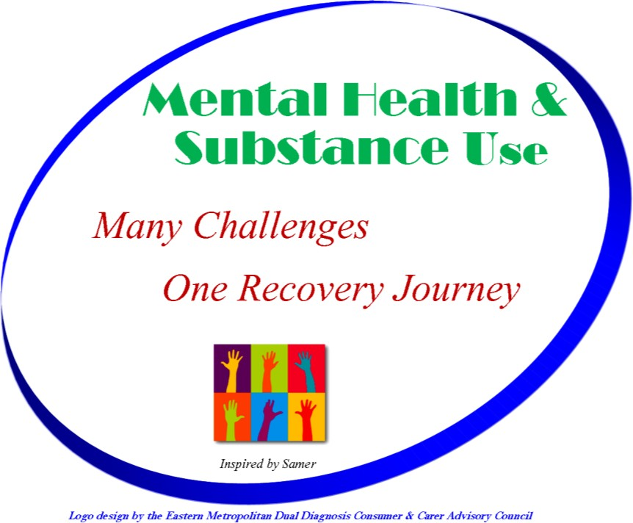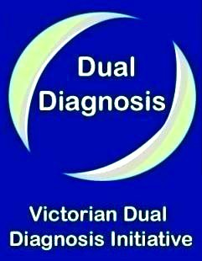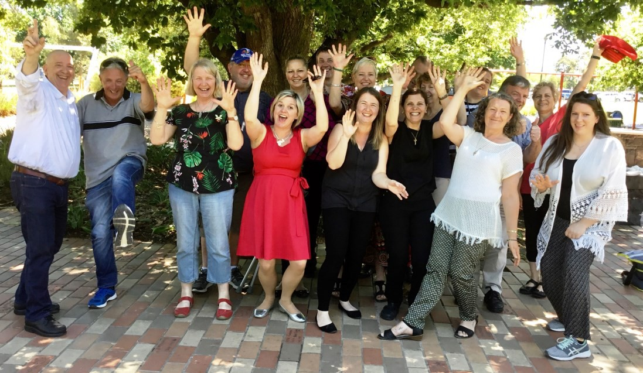

Inside this Issue
The Council logo was designed in 2016 with the theme Many Challenges, One Recovery Journey that reflects the mental health and /or substance use issues our members have experi- enced in their lives. The logo has been printed onto tee-shirts and a ‘tear-drop’ flag for display at the various events our members attend - promoting awareness of dual diagnosis through engagement with members of the public, or at peer- led events across Melbourne. At the most recent World Mental Health Week Expo held at Mooroolbark, our flag was displayed for the first time. During the event, 50 of our show-bags were handed out with information about dual diagnosis and our work across the region - as well as contact information for sup- port and treatment services in the East.

Research report - Gavin Foster
2
3
4
5
6

Sarah Martin - Wellington House Art Therapist New EDDS Appointments
Fred`s Tips for Healthy Living

All Together - Russell Chilcott

The Tuesday Club - Kellie O`Connor
The Eastern Dual Diagnosis Service (EDDS) EMHSCA and the NDIS—Bronwyn Williams
The DDCCAC 2017 end of year celebration, Halliday Park Mitcham

Edition Number 2 Autumn 2018
Research Report |  | 2012 survey. There was a noticeable difference shown via a re- duction of more ‘positive’ attitudes between the 2012 and 2016 data. There also appeared to be some correlation between less positive answers and an increase in more neutral answers, po- tentially representing a slipping of positive attitudes from staff in general.  A drop in more positive attitudes between the 2012 and 2016 surveys was matched by a 28% drop in those who had attended dual diagnosis focused training in 2016. Information from these surveys suggests that dual diagnosis training in the eastern met- ropolitan region is a viable way to support staff to hold more positive attitudes when working with people with co-occurring mental health and alcohol and drug problems. For information about this survey please contact Gavin Foster via email:  gavin.foster@easternhealth.org.au  Sarah Martin Portfolio Holder  Sarah Martin is a registered Art Therapist at Wellington House Residential Detoxifi- cation Unit in Box Hill. Along with her passion for the therapeutic use of arts in healing, she has 20 years’ experience working in varied community services, including 5 years in the alcohol and drug sector. Her caring nature and lived expe- rience as a carer offers a gentle approach and understanding in support for others in their recovery.  In my role over the past two years as Group Activities Coordinator at Wellington House I’ve been privileged to work alongside Fred Murray and Denise Damouni who facilitate the weekly Dual Diagnosis Consum- er and Carer Advisory Council peer-led support group, a valued part of our groups program here at Wellington House. During this time I have witnessed not only the benefits to our clients but also the personal growth and self-confidence of the facilitators themselves. Their genu- ine approach and openness creates a safe space for group members to share their experiences. For many, it’s the realisation that they are ‘not alone’ in experiencing the numerous effects of mental health and ad- diction that connects them to the group. Many comment that they feel understood and heard which creates a further willingness to share the activities and supports that have benefited them during their own re- covery journeys. Most importantly I find the greatest value of the  group is that clients state they are given HOPE.
Gavin Foster is Manager of the Dual Diagnosis and Service Development teams which are situ- ated within the Mental Health Programme at Eastern Health. In this article, Gavin reports on a survey-based research project which assessed staff attitudes concerning their work with dual diagnosis consumers and what influence dual diagnosis focussed training might have had on these attitudes
In 2012 and 2016 the Dual Diagnosis Working Group and the Dual Diagnosis Consumer and Carer Advisory Council conduct- ed the Dual Diagnosis Attitudes surveys to gain better under- standing of staff attitudes towards people with co-occurring mental health and substance use problems. A key focus was to identify the impact of training on attitudes and potential areas for change in the delivery of training. The first survey was conducted during August and September in 2012. The goal of this survey was to gain a baseline of attitudes and to identify areas of learning for mental health and alcohol and drug service staff that would enhance their engagement of dual diagnosis consumers through increased confidence and knowledge of dual diagnosis specific recovery and treatment interventions.

The Attitudes survey was completed by 186 staff; 50% were from clinical mental health (CMH), 17% from alcohol and drug services (AOD) and 33% were from mental health community support services (CMHSS). 73% of respondents had complet- ed dual diagnosis training in the preceding three years. Initial review of the survey data shared some consistency with anec- dotal information arising from informal staff reports that there was a difference in favour of more ‘positive’ attitudes from staff who had attended a Dual Diagnosis focussed train- ing programme in the previous three years. This was support- ed by a breakdown of responses from staff who had complet- ed training and those who had not.

The second survey was conducted during March to May in 2016. This survey was completed by 110 staff from clinical mental health (21% of survey participants), 42% were staff of alcohol and drug services, and 26% were staff of mental health community support services. On this occasion, 45% of respondents had completed dual diagnosis training in the preceding three years - a decrease of 28% as compared to the
 |  | Wellington House is a part of Turning Point Eastern Treatment Services (TPETS) and offers clients residential admission for withdrawal management of alcohol or other drugs. TPETS also provides a range of no-residential treatment services from their centre at 43 Carrington Rd Box Hill. Admissions to Wellington House are arranged following assess- ment by a Carrington Rd staff member. TPETS appointments can be made by calling 1800 778 278 - the Eastern Region Community AOD services contact number.
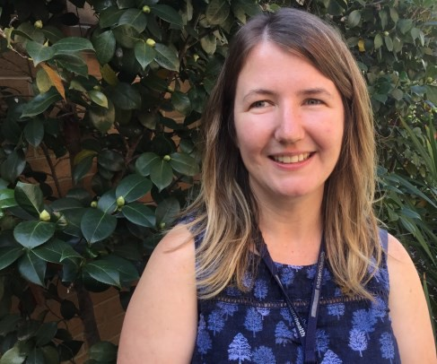

Edition Number 2
The Meteor
Autumn 2018

New Appointments Peter Fairbanks
I joined the Eastern Dual Diagnosis team in October 2017 after
working at Spectrum State-wide Personality Disorders Service for 18 years (where has the time gone!). My background disci- pline is Social Work and before that I was trade teaching and have also worked as a motor mechanic (quite a change). My wife and I have done foster care for many years and one of my key values are developing and maintaining relationships. Until recently I played goal keeper with my adult son’s indoor soc- cer team. My role in the Dual Diagnosis team includes co- coordinating our monthly Linkages network meetings, provid- ing consumer consultations to case managers and training to teams and services across the eastern region. I have also joined the Mental Health Working Group that is a collabora- tion with the Dual Diagnosis Consumer and Carer Advisory Council. I received a very warm welcome from Council mem- bers at the 2017 end of year BBQ which was a great way to meet and greet the many people I will be working with in the future. peter.fairbanks@easternhealth.org.au
towards better life outcomes is what HYDDI is all about! HYDDI is part of the VDDI (Victorian Dual Diagnosis Initiative) and sup- ports the Homeless Sector (SHS funded) services and supports staff in capacity building training and education, and by direct support to our most vulnerable youth. HYDDI can be contacted for primary and secondary consultation at a time where it may be difficult to engage this often transient population of young people. HYDDI is purely outreach. I COME TO YOU. If you wish to know more or to discuss how I may best be of assistance please contact me at carol.addicoat@easternhealth .org.au

Fred`s Tips for Healthy Living
Fred Murray has been a member of the Consumer & Carer Advisory Council since 2011 and co- facilitates the weekly Group sessions at the Wel- lington House Residential Detoxification Unit at Box Hill Hospital with Denise Damouni DDCCAC carer member and staff representative, Art Thera- pist Sarah Martin. In this column Fred discusses the importance of healthy sleep

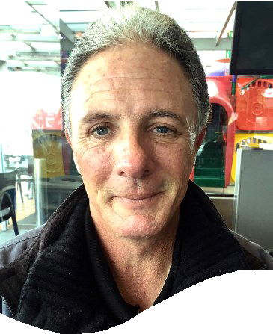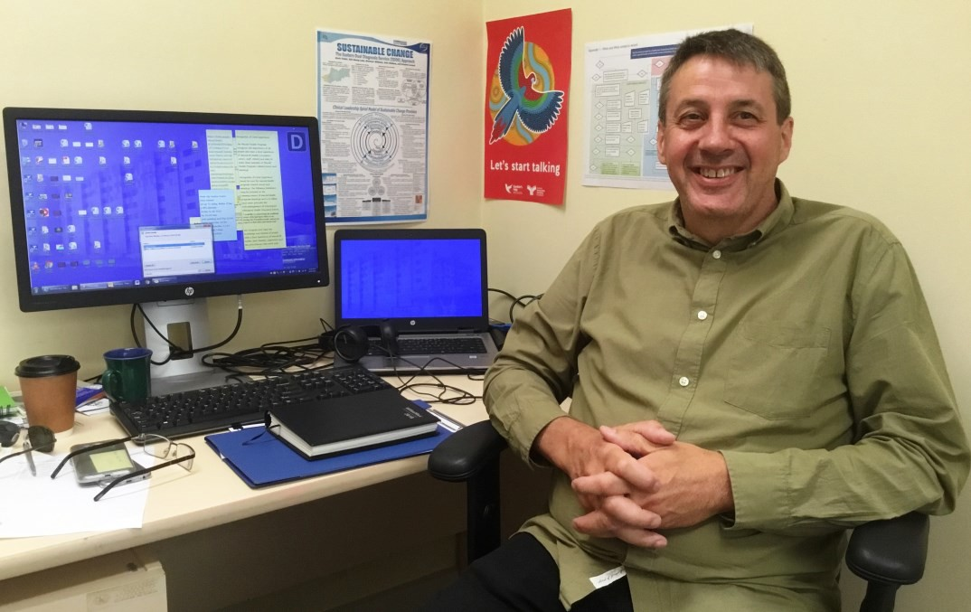
Edition Number 2 Autumn 2018
The Meteor
News from the Dual Diagnosis Service
& Dual Diagnosis Consumer & Carer Advisory Council

3

Carol Addicoat
It is common to have sleep problems. Sleep deprivation can cause health issues such as not being able to function well at work or school through drowsiness or poor concentration, or can be the result of an underlying mental health condition such as depression. During my own recovery from alcoholism and de- pression my ‘time-clock’ needed to get re-balanced. I`m alcohol free now which has helped me get back to a regular pattern of sleep. I also had to make a big change in how much coffee I was drinking each day. This was one cause of my poor sleep - at one time I was drinking up to 12 cups a day. As a result of cutting down I haven`t been so jittery or feeling as anxious, and my mood has improved. Here are my tips:

Only take sleeping pills prescribed by your doctor or psychiatrist

Don`t watch the television or use your mobile phone in bed. Keep bedtime as sleep-time!
Reduce or stop light from coming into your bedroon through the window or door

Get regular exercise during the day and try not to get into a pattern of day-time naps
Try a herbal tea or perhaps a warm milk drink as you get ready for bed

Lavender or essential oils can provide a soothing smell at bed- time as well as listening to some soft relaxing music
Thanks, from Fred

Hello to all. My name is Carol Addicoat and I am the recently appointed HYDDI (Homeless Youth Dual Diagnosis Initiative) clinician. We farewelled John Mullane in 2017. John held this position since the inception of HYDDI in 2010. He did a great job and made an impact in a much needed area of support. Prior to coming to Eastern Health and Family Access Network, I held the HYDDI position for 3 years in the Western Region of Melbourne. I find the work inspirational. Working with young people and supporting them to make changes earlier in life

Edition Number 2
The Meteor
Autumn 2018

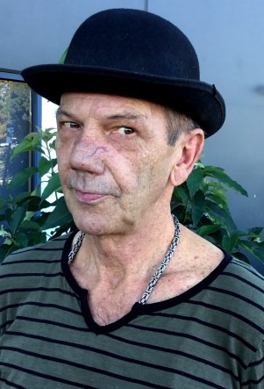All Together by Russell Chilcott

Russell Chilcott is a member of the DDCCAC and an associate editor of The Meteor. He is the peer- facilitator of the dual diagnosis Group programme at the Chandler House Community Mental Health Centre at Upper Ferntree Gully. He is joined each week by a dedicated member of the clinical team. This article describes an innovation Russell has introduced to enhance engagement and participation of group members.

It is both ironic and a joy to be a peer worker. To actively wit- ness and work with people wading through the tribulations of coping with the hand-in-life they’ve been dealt, be it as a con- sequence of trauma, unfortunate genetics or to have become prisoners of their own misconduct and circumstance. Some folk may have elements of all the above. I’d like to relate a particular experience serving at Chandler House Community Mental Health Centre. This is an outpatient service.

This centre has been home for many years in what was the original Angliss Hospital where I lead a weekly group discus- sion, in tandem with Kellie O`Connor, a member of the clinical team. The merits of such a peer–led group, was recognized by Chandler House management over a decade before. Then in 2013, under the auspices of the Dual Diagnosis Consumer and Carer Advisory Council the Group Programme was re-booted and called the Tuesday Club; and welcomed by all concerned. There are people ‘up the chain’ at both Chandler and in our Mental Health Working Group who should be named and thanked, and they will know who they are - but I will resist to stay focused only to mention Kellie who is instrumental in the groups` four year success and engages the roles of co- facilitator, advocate, head hunter and nosh provider.

Once the group, which we call The Tuesday Club, was estab- lished and ongoing it didn’t take long before I’d used every tool in my box of group facilitation skills. For a while, I was able to rework and reintroduce material, but needed to space that out well at each discussion because now there were reg- ular members and they didn’t want to be told a variety of things ten different times ten different ways - and you’d know it, because they’d tell you, or not return next week. Gone! Nor do the group ‘members’ want to hear you banging on about addiction and mental health even if it is yours. Why? Because
they’ve heard it all before - coloured every which way, from the best. They’ve seen more clinicians, caseworkers, psychiatrists, social workers, law courts, IPUs, rehabs, CCUs and detox’s than you could poke a stick at. Some will cycle through them again, and again. For these are seasoned fighters, and also now they are emancipated community members with a certain amount of independence and lots of free will. So why do they come? Well, the standout value I see in this group is the growing interaction and respect fostered by the members. The social and reintegra- tion aspect, talking with those who have had reasonable success with it, and others who wish to do better for themselves. A ca- maraderie with the best intentions has developed. A concerned voice might be raised if a group participant hasn`t been sighted for a time. Some of the group are now attending other commu- nity courses together, and the like. To aid self- determination, direct attention to current behaviours, and how to create op- portunities, is to provide a blank canvas about a subject matter and not taint it with your own thinking, but provide the vehicle and let the others steer it. By doing this you will find the pot- holes.

This process can be appreciated using the following real exam- ple. Some folk in the group confided that their lack of the most basic education compromised their wants and conceivable am- bitions of assimilation. From that discussion, an agreement was made to try some ‘out-loud’ reading. The following week I brought in some appropriate books - (two particular recommen- dations; I Had A Black Dog by Mathew Johnstone and The Brown Bottle by Penny Jones). Their large spacious print and full page illustrations enable each reader in turn to preview the text themselves, then show the picture to the others in a slow wide sweep (like a teacher in preps), and turn the book back to them- selves and read a passage to all, before passing the book on to the next person. As this unassuming activity unfolded, it was clear that here was another mechanism that can be used to engage a group in a different way. It seemingly evoked positive memories, stimulated teamwork and socialising whilst gaining behavioural messages in a subtle and enjoyable format. As well there worthy discussions have followed. So as a result of the positive impact this medium has, it is now part of my group re- sources. Good day, and good luck

Edition Number 2 The Meteor Autumn 2018
The Tuesday Club - Kellie O`Connor  I am employed as a Senior Clinician / Case Manager at Chan- dler House Adult Mental Health Service in Upper Ferntree Gully. My role is to provide case management for clients with a serious mental illness and co-existing diagnoses such as sub- stance dependence. I have been working alongside Russell Chilcott since February 2013 where my role is co- facilitator of the Dual Diagnosis Group, the Tuesday Club. Our group is part of a mental health service-wide Dual Diagnosis group pro- gramme and is based on a peer-led model that aims to engage consumers experiencing a combination of mental health and substance use challenges, and to support them in achieving their personal recovery goals, in a safe, confidential and re- laxed setting.  This is the first experience I have had working alongside a peer  -worker and not only have I found it a very rewarding experi- ence personally and professionally, but I have also learnt so much along the way. As a peer worker, Russell has the ability to connect with consumers in a unique way where there is a sense of shared understanding, respect and support that is always there without having to label it in words, forms, or policy statements. Russell has such a calming, positive pres- ence in the group and I have seen just how much mutual re- spect there is. He really fosters this in our group members and which has now grown beyond the group sessions themselves, to include sharing social activities. There are consumers who attend each week, rain hail or shine. This has often been the first place they feel truly accepted and comfortable and have been able to form friendships out of it.  The Tuesday Club has become an integral part of their week. I must say it is a highlight of my week too. Not only do we have good food and some laughs, but it is also a safe-space where we can talk about stuff going on, and Russell will bring set ac- tivities for us to do, whether it’s setting goals for the week, information on cutting down smoking, improving diet or sleep. The discussions include talking about recovery, but not in a forced, autocratic way. We share the tough times and cele- brate little successes along the way whether it’s to sing happy birthday, celebrate a meal cooked, giving up the alcohol, do- ing a course, celebrating relationships, etc. To me this is what | recovery is about. The opportunity for consumers to feel vali- dated, heard, respected and listened to and encouraged to pursue their own recovery that is meaningful to them, in their own time. The ongoing expansion of the peer-worker role is exciting and I thank Eastern Health Dual Diagnosis Service for leading the way on this. But an especially big thank you goes to Russell, whose work is truly valued by all at Chandler House. Thanks also to all others involved in this program, and for their ongoing support of the Tuesday Club  Kellie O`Connor and Russell Chilcott  The Eastern Dual Diagnosis Service  Our team works across the eastern region of Melbourne to provide services to clinical mental health (CMH), alcohol & drug (AOD), homeless support agencies and mental health community support services (MHCSS). We work with individu- als, teams and services guided the Victorian Dual Diagnosis Initiative Service Development Objectives (SDO`s) described in its Key Directions policy document*. Our team provide consul- tations directly with consumers and their case managers, or by secondary consultation and education and training at team in-service sessions or for longer training events. We stand  proudly alongside the Consumer & Carer Advisory Council in their important role in supporting consumer recovery.  *http://www.vaada.org.au/wp-content/  Contact us at EDDS@easternhealth.org.au
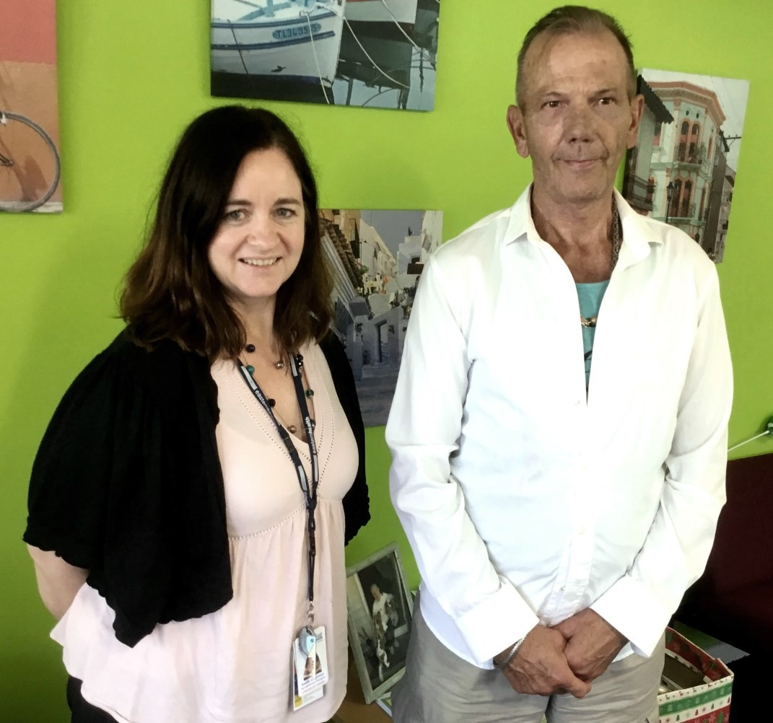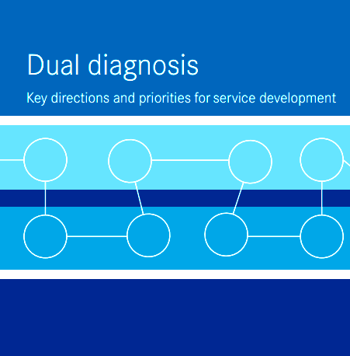

Edition Number 2 The Meteor Autumn 2018
What is EMHSCA ? - Bronwyn Williams  Bronwyn Williams is a mental health nurse who brings to her new NDIS role a wealth of experi- ence over many years of work at Eastern Heath. She is passionate about removing ser- vice treatment barriers to ensure better and more collaborative participation for consumers who experience both mental health and sub- stance use problems, and their families.  The Eastern Mental Health Service Coordination Alliance (EMHSCA) has been operating for 10 years in the region and provides a key platform for service coordination and partner- ship for 25 health and community services. The EMHSCA vision is to ensure that people who experience mental ill-health and co-occurring concerns have access to appropriate, responsive and collaborative services to assist with the multiple facets of their individual recovery journey.  This region has signed up to the EMHSCA Shared Care protocol which supports collaborative practices, and 25 organisations are party to the EMHSCA Memorandum Of Understanding (MOU). All member agencies offer a small contribution to workforce development and four significant events are held each year at no cost to participants. Staff from EMHSCA partner organisa- tions participate in numerous cross-sectoral forums providing networking, service orientation, service coordination capacity building, linkages and problem solving. EMHSCA partners devel- op strategies for improving their collective response to people who require multiple supports. Various system reforms have challenged this collaborative work over the years and EMHSCA has sustained their partnerships and good will in spite of these. EMHSCA has as one of its strategic aims the preservation of its valued partnerships and collaborative practices with the intro- duction of the National Disability Insurance Scheme (NDIS) to the Eastern Metro Region from November 2017.  Currently the strategy involves providing a forum to service pro- viders to enhance their understanding of the issues and the importance of partnerships. The first forum was held on the 29th August 2017 and catered for 250 staff. The next forum is sched- uled for the 17th May 2018 at the Box Hill Town Hall. This forum will aim to unpack the various elements of NDIS and the role of service providers. Services have participated in mapping what | they provide with these system changes and an NDIS tab has been added to the EMSHCA shared repository to provide useful info and links to staff, consumers, their families and carers. See  https://www.easternhealth.org.au/services/mental-  health-services/eastern-mental-health-service-  coordination-alliance#ndis  I have just been appointed to a new role as the Eastern Health Mental Health NDIS Program Lead. This will involve supporting the clinical Mental Health staff to understand their role when working with consumers and carers and the NDIS, to identify systems and processes that require adjustment to work practic- es within an NDIS environment; including facilitating partner- ships that enhance service provision for people who experience mental ill-health (NDIS and non-NDIS), improving consumer families, and carers awareness of the NDIS, and escalating is- sues with the aim of timely problem-solving for NDIS partici- pants.  As the project officer for EMHSCA, and with this additional role leading the interface for clinical mental health services and NDIS, I have become a key contact person in this region to sup- port services as they seek to understand the NDIS and provide information and a useful response for people who access their services.  The following links may support an improved understanding of the NDIS for people who experience mental ill-health. Open the links listed in the box below for more information.  Bronwyn Williams  Eastern Health Mental Health NDIS Program Lead/ EMHSCA Project Officer  Level 1 Upton House, 131 Thames St, Box Hill Telephone : 8396 3504 or Mobile : 0434 608 544  bronwyn.williams@easternhealth.org.au  For all NDIS information visit the NDIS website at https://www.ndis.gov.au/, or contact 1800 800 110 or reply to VICEast@ndis.gov.au  For Psychosocial Disability support under NDIS go to http://reimagine.today.  For NDIS Events near you visit https://www.ndis.gov.au/news/events/vic.html
